NAME___________________________ PERIOD

ATLAS INTRO: Getting to know your ATLAS

WORLD FACTS
Use World Facts on the inside cover of The Nystrom World Atlas to answer the following questions:
- Which continent makes up about 30% of the world’s land area?
- What is the highest point in South America?
- Which ocean is the largest in area?
- How many of the world’s largest lakes are in North America?
- What are the two largest urban areas?
- What are the projected populations for these urban areas in 2025?

Use the Table of Contents (this page directs you to the various atlas sections) on page 2 to answer the following questions:
On which page number do the following atlas sections begin:
- Asia
- Index of Places
- North America
- Middle East
- Australia

Use the Land Cover Map Legend on page 3 to complete the following sentences:
- Cropland is represented by the color___________________.
- Glaciers and polar sea ice are presented by the color________________.

Use the Political Relief Map legend on page 3 to answer the following questions:
- What does a small black square represent?
- For city symbols, what do the sizes of dots and letters indicate?

CONTINENTS AND OCEANS

Use the Continents and Oceans map on page 2 to answer the following questions about continents:
- Which continent is on the same landmass as Europe?
- Which continent(s) border the Arctic Ocean?
- Which continent is northwest of Australia?
- Which continent is south of South America?

Use the Continents and Oceans map to answer the following questions about oceans.
- Which ocean is between South America and Africa?
- Which ocean is farthest north?
- Which ocean is between Asia and North America?
- Which ocean is between Australia and Africa?
- Which ocean surrounds Antarctica?

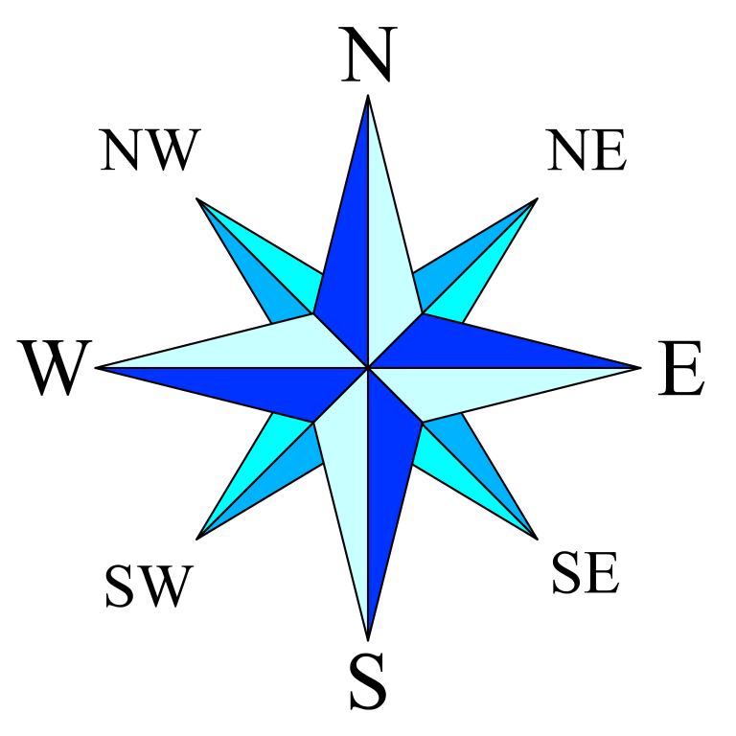
Imagine you are traveling between continents, from the center of one to the center of another. Use the Continents and Oceans map to determine which direction you would need to travel and write the direction down. (HINT: USE THE COMPASS ROSE)
- Europe to South America
- Asia to Africa
- Australia to South America
- Africa to Europe
- Europe to Antarctica
- North America to South America

