Name:_________________________________________________________________Period:_________

Use the graphics and written explanations of the eightfold path below to help you fill out the chart:
- Right understanding (seeing things as they really are, and not how you think they are)
- Right thought (kind thoughts, not cruel ones, giving things up and not being greedy)
- Right speech (not lying, being rude, or abusive; and not gossiping)
- Right action (saving life, not destroying it, not stealing, being respectful in relationships)
- Right livelihood (earning a living without hurting others-people or animals)
- Right effort (working hard to understand truth and stay with what is right)
- Right mindfulness (being aware of actions, words, and thoughts at all times)
- Right contemplation (learning to meditate without losing concentration)

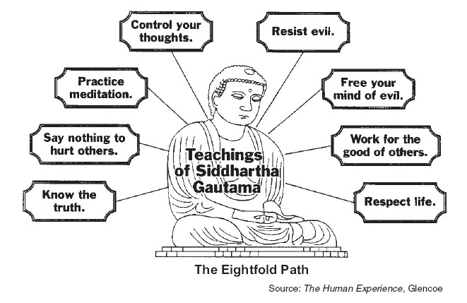
Dilemmas
- Cindy Angle comes up to you and starts punching you out of nowhere. What do you do?
- Ms. Smith is leading a group of people out of a cave on the coast of St. Thomas, and becomes stuck in the mouth of that cave. In a short time, high tide will be upon them, and unless she is unstuck, they will all be drowned except for Ms. Smith, whose head is out of the cave. Fortunately, (or unfortunately,) someone has with him a stick of dynamite. There seems no way to get the Ms. Smith loose without using the dynamite which will inevitably kill her; but if they do not use it…everyone in the cave will drown. What do you do?
- You really want to take Marty Bagley to the upcoming dance in March, but you heard that she is going with Bradon Williams, so you decide to ask another girl instead. The day of the dance comes, and it’s 30 minutes until you need to go pick up your date, when you get a phone call. It’s Marty Bagley! Apparently, no one ever asked her to the dance, and she is wondering if she can go with you. What do you do?
- Miguel Jordan has several friends, including Jack Jones and Corbin Clarkson. Jack has recently started dating Abby Sanchez. He is convinced this is a long-term relationship. However, Miguel soon found out that Abby is already dating Corbin Clarkson! One day, Corbin calls up Miguel and tells him that he’s afraid Abby is cheating on him. Miguel is friends with all three of them. What does he do?
- Bryan Bennet father has told him that if he can score a 100 on all of his walkaways, that he will buy him an Xbox 360 with Kinnect! So far, he has received a 100 on all of his walkaways, but he has 1 more left: History! Bryan hates history and hasn’t studied. :s However, when he goes to turn in his history walkaway, Ms. Smith leaves the classroom with the answers lying on the desk! (This will never happen). Bryan quickly changes his answers and turns in the walkaway. He’s gotten off scott-free…but not quite. Alexis Robertson has seen what has just transpired. Alexis is good friends with Bryan. What does she do?

Dilemma | How We Might Deal With It | How a Buddhist Might Deal With It

