Name_____________________________________________ Period_________
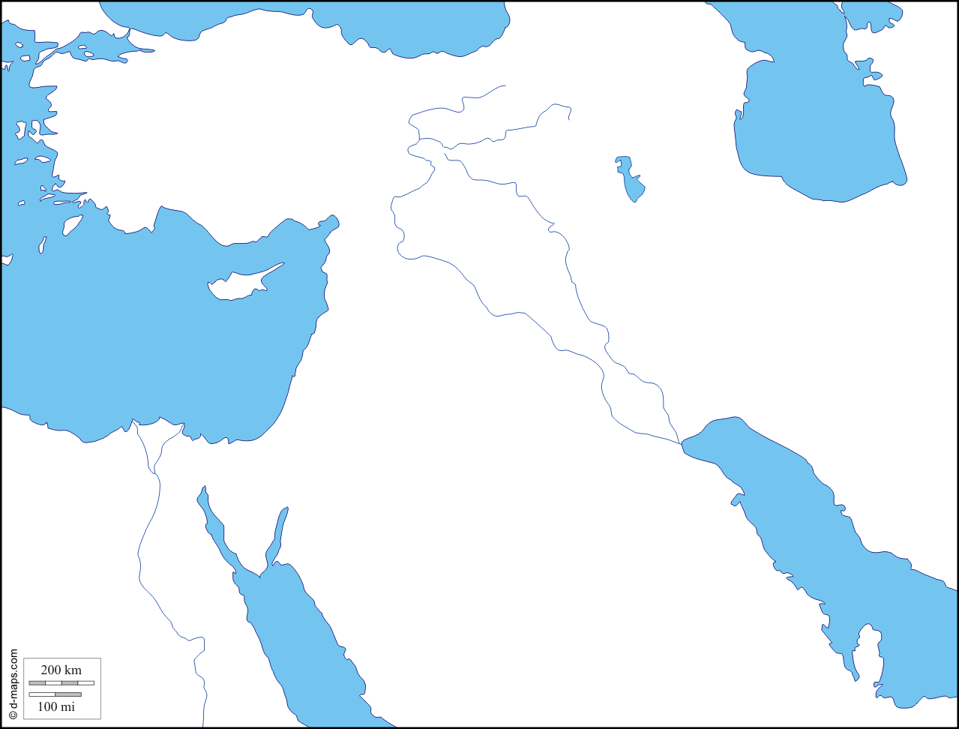
The Middle East: Mesopotamia
The Fertile Crescent: Locate on a map and color green
- The Fertile Crescent
- A strip of _____________________ stretching from the _____________________ to_____________________________________.
- The cradle of ___________________________.
- Surrounded by _________________ and _________________________________.
- Tribes of wandering herders often ___________________ the valley, ______________________ it, and established ______________________.
- The history of the fertile crescent is one of repeated ___________________ and __________________.
- Mesopotamia
- Mesopotamia: “______________________________________________” in Greek.
- The _____________________ and _____________________ rivers flow down from the _____________into Mesopotamia's ___________________________________.
- Every year, the rivers bring _______________ to nourish the soil.
- First farm settlements formed around __________________________.
- The Rise of the Sumerians
- Farm settlements gradually developed into __________________ between 4000 and 3000BC
- The cities became the _____________________, _____________________, ___________________, and ________________________ centers of civilizations.
- The Rise of the Sumerians
- In southern Mesopotamia, a people known as the ___________________________ developed the world’s first civilization.
- It is unknown when the Sumerians settled in Mesopotamia or where they were originally from.
- By _______________________ BC several hundred thousand Sumerians were living in southern Mesopotamia.
- City States
- The first major cities in Sumer had about ______________________ residents.
- By 2,000 BC some of Sumer’s cities had more than _____________________ people.
- A city state is _______________________________________________________________________________________________________________________________________________________________________.
- The amount of countryside controlled by each city state depended on its ________________________.
- City states fought each other to gain more _____________________.
- Warring Cities
- City states built up strong armies and thick walls around their cities for _______________________.
- Individual city states gained and lost power over time.
- _____________, __________________, ______________________ were all powerful city states.
- Government
- Sumer’s earliest governments were controlled by _________________________________.
- During war time, ____________________________ would take over. Eventually, some commanders kept control for the government. This paved the way for ___________________________.
- Sumerian Achievements
- Writing
- Wrote with a tool called ___________________.
- Letters were __________________shaped.
- The writing was called __________________________________.
- Architecture
- Invented _____________________________________.
- Invented temples known as_______________________________________.
- Scientific Achievements
- May have been the first people to use the ______________________.
- Used numbers based on _____________________.
- The concept of sixty minutes/seconds was developed by the Sumerians.
- The Empires of the Fertile Crescent
- The Akkadians
- A people known as the _____________________________ lived just north of the Sumerians.
- They spoke a different ____________________, ____________________________________.
- Origins
2,330 BC
- A man named ____________________ formed a ___________________________ army and launched a series of wars.
- He defeated all the city states of Sumer and northern Mesopotamia.
- He formed the world’s first _____________________________.
- Fall of the Akkadians
- Rulers after Sargon were ______________________and had trouble protecting the empire.
- A century after Sargon’s death new waves of invaders swept through the fertile-crescent and the empire collapsed.
- City states once again began to war against each other.
- The Babylonians
- In 1792 BC a strong ruler named _________________________________came to power in Babylon.
- He conquered most of ______________________________________.
- Hammurabi
- Outstanding political leader and ___________________________________.
- Created the Code of Hammurabi.
- Collection of ____________________laws concerned with all aspects of life in Babylon.
- Punishment was harsh and based on the “____________________________________” principle.
- The laws found in the code deal with day-to-day laws in Babylon governing ___________________________________________________________________________________________________________________________. The code also lists penalties for _________________ those laws.
- The Babylonians were also __________________________ and conquered by outside forces.
- Code of Hammurabi
- ________________________: “If any one steal cattle or sheep, or a pig or a goat, if it belong to a god or to the court, the thief shall pay thirty-fold; if they belonged to a freed man of the king he shall pay tenfold; if the thief has nothing with which to pay he shall be put to death.” (# 8)
- “If any one break a hole into a house (break in to steal), he shall be put to death before that hole and be buried.” (# 21)
- ________________________________: “If any one bring an accusation of any crime before the elders, and does not prove what he has charged, he shall, if it be a capital offense charged, be put to death.”(# 3)
- _________________________: “If any one find runaway male or female slaves in the open country and bring them to their masters, the master of the slaves shall pay him two shekels of silver.” (# 17)
- “If a slave say to his master: "You are not my master," if they convict him his master shall cut off his ear.” (# 282)
- Code of Hammurabi
- __________________________________: “If any one hire a ferryboat, he shall pay three gerahs in money per day.” (# 275)
- _________________________________: “If a builder build a house for some one, and does not construct it properly, and the house which he built fall in and kill its owner, then that builder shall be put to death.” (# 229)
- Other Empires
- The ____________________________________, ____________________________, and______________________________ each came to power, but eventually fell making way for new empires.
- The _________________________ eventually came to power in 539 BC and ruled for several centuries.
- Countries in the Middle East

- Turkey
- Syria
- Afghanistan
- United Arab Emirates
- Iran
- Saudi Arabia
- Oman
- Jordan
- Cyprus
- Iraq
- Kuwait
- Israel
- Qatar
- Yemen
- Lebanon

