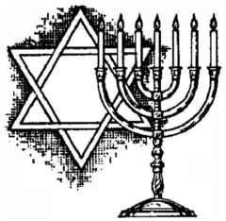
JUDAISM
Name:

Period:
- HISTORY
- IMPORTANT FIGURES & LEADERS
- SECTS/ BRANCHES
- FUNDAMENTAL/BASIC BELIEFS
- SACRED SPACES & PLACES OF WORSHIP
- SACRED BOOKS OR TEXTS
- DIETARY LAWS OR GUIDELINES
- HOLY DAYS & HOLIDAYS
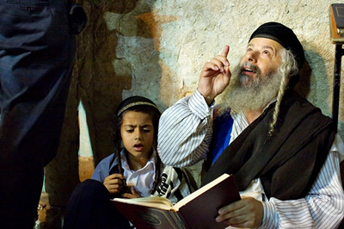

- MARRIAGE & FAMILY ROLES TRADITIONS
- RELIGIOUS “CULTURE”
- MODERN ISSUES & CHALLENGES

