Nasima Khatun, a Rohingya
by Katie Arnold 17 Sept 2017 (Al Jazeera)
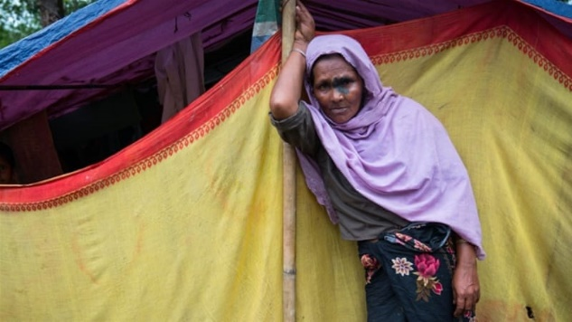
Nasima Khatun, 60, comes from Rakhine State, Myanmar, which she fled a few weeks ago.

"My name is Nasima Khatun and I am 60 years old. We lived a quiet life before the crisis, my husband was a fisherman and we had three daughters - we lived very well for Rohingya. Although we encountered some pressure from the military, we did not face any problems with regards to food or shelter. When the military started firing their guns in our village, we all ran in different directions. I was hiding in the jungle when someone told me my husband had been shot. I felt helpless and afraid. The military took over the village so I could not return to bring back the body, we had to leave him there and quickly move to Bangladesh. I travelled with my daughters and some neighbors from the village, we could not carry anything with us, so we just ate and drank whatever we found on the way. One day, we passed an abandoned shop which we looted - that was the only real food we ate during the 10-day journey; we were so hungry. I cried and cried the whole way, so my neighbors took pity on me and paid for our boat trip across to Bangladesh. I was so sad to leave Myanmar, I lost my husband there, my house, my land and everything I own. We've managed to build a shelter here, and the local Bangladeshis have supported us with food donations. But I have no opportunity to earn money, there is no work for us to do. What type of future can we have if we don't have any money? Everyone wants to go back to Myanmar, but I don't think that will ever be possible, it will never be safe there again. If we go back, we'll be either tortured or killed. I believe the world is watching our situation. My request is that they empathize - that the world hears our stories of sorrow and death and imagines how they would feel in our shoes.”

Arba Khatun, a Rohingya
by Katie Arnold 18 Sept 2017 (Al Jazeera)
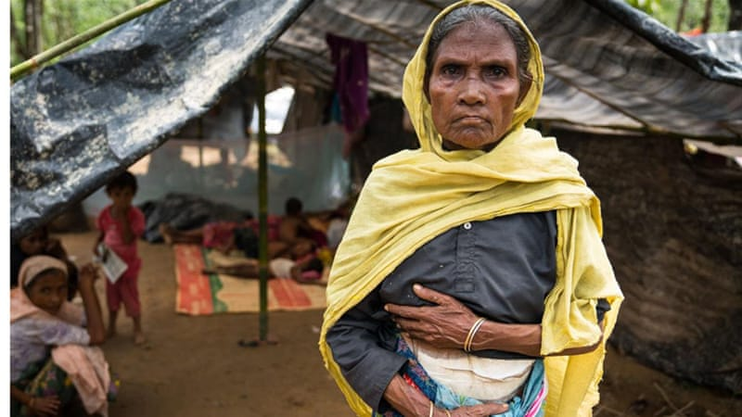
Arba Khatun, 50, comes from Rakhine State, Myanmar, which she fled a few weeks ago.

"My name is Arba Khatun and I am 50 years old. Before the crisis, we lived a fairly good life: We had domestic animals, we had a farm, we cultivated lots of different crops like rice and coconuts. Somehow, we managed. My husband died 15 years ago, so I lived with my son and his family. When I was younger, I used to love working on the farm, but now I am old, so my son does most of the work. I cannot remember what day it was, but I had just woken up and was washing my face when the military came to our farm and stole our animals. That is when they fired their gun and a bullet hit my stomach. Luckily, it did not go too deep, but it was very painful and bleeding a lot, so my son took me to a nearby doctor. When we returned the whole village had burned to the ground. My son carried me to the mountain, we found his family.
We slept there for three days, then he carried me to Bangladesh. We could not bring anything with us because my son was carrying me, and his wife was carrying their two children - it was a difficult journey and it took us 12 days. We heard there were some problems at the border, but we crossed easily. I am happy to be in Bangladesh because we are safe here. My wound is healing so I am walking around a lot more, too. But we could not bring any food with us and we have nothing to eat - we have not received any support; we are so hungry. My son would ask the world to help us get our country back, but I don't want to go there again, we will never be safe in Myanmar, we need to do the best we can here in Bangladesh."

Ahessan, a Rohingya
by Katie Arnold 14 Sept 2017 (Al Jazeera)
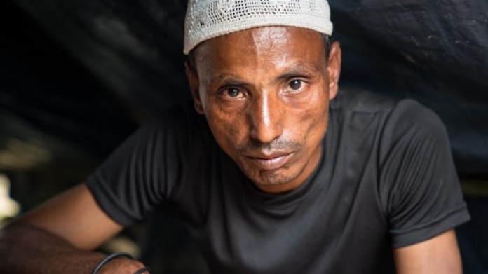
Ahessan, 30, comes from Rakhine State, Myanmar, which he fled in recent weeks.

“My name is Ahessan, I am 30 years old. Before the crisis, I was a farmer in my home village of Chin Khali, but I also taught English to children after work, so I was a very busy man. On the morning of August 25, I was having breakfast with my family when the military entered the village and started firing their guns at us. It was indiscriminate and five members of my family died. I found my mother lying on the floor with bullet wounds in her back, my sister lay nearby with stab wounds to her face and body. It was the most distressing scene I have witnessed, but I did not have time to be sad as I was scared the military would shoot me, too. A soldier tried to rape my sister, she resisted but they still beat her up. She is so traumatized that she has not spoken a word since, and she can barely move - my brother and I carried her here with some bamboo and a blanket.
We saw many terrible things on the road to Bangladesh - there were dead bodies, children crying and old people starving. When we reached the border there were over a thousand other Rohingya trying to cross the river - eventually, we found a boat which took us across. Our life in Bangladesh is very miserable - we do not have proper shelter, there is no sanitation and there is not enough space for all the refugees to sleep. We are living, but it is so horrible we might as well be dead. I worry that the Rohingya people will die out soon - if we stay in Myanmar then we will be killed, but here we have no life. I believe the whole world is helping and supporting us and for that, I am very grateful. But I want the world to put themselves in our shoes - we are humans in the same way that you are humans, yet you are citizens of a country and we are not. I appeal to the whole world, please let us be citizens of a country, let us live like you.”

Noor Kajol, a Rohingya
by Katie Arnold 15 Sept 2017 (Al Jazeera)

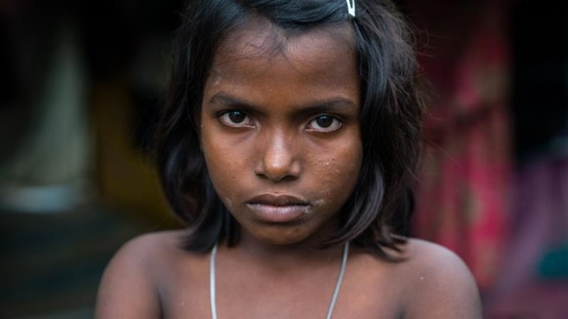
Noor Kajol, 10, comes from Rakhine State, Myanmar, which she fled in recent weeks.

“My name is Noor Kajol, and I am 10 years old. I was very happy in my old village because I was studying at the madrassa - I liked learning about the holy Quran, and I wanted to memorize all of it. I lived with my family; there were seven of us in total. The house was not very big, but I liked living there. We had to flee our homes because the military started shooting us. I was inside the house with my father when they shot him through the window. The bullet hit him in the head, he fell on the floor, and a lot of blood was coming out of his head. I was really scared, and I was crying a lot. We ran away, leaving my father in the house. The military burned the house down, even though my father was still inside. We had to run away to the forest and hide in the trees. We then walked for three days to get to Bangladesh. It was difficult for me because I was hungry, and I missed my father a lot. Other people helped us cross the border for free, which was very nice of them. We travelled in a boat with an engine, but I did not enjoy the boat ride because I still missed my father. He was a woodcutter, and everyone liked him. He was a good-natured man, and he loved me a lot. I am very unhappy in Bangladesh because I miss my father so much. It is also very dirty here; there are no toilets or bathrooms. I would like the world to help us get our own country back or offer us another country that we could live in.”

Mohammed, a Rohingya
by Katie Arnold 9 Sept 2017 (Al Jazeera)

Mohammed Soye, 33, comes from Buthidaung town in Rakhine State, Myanmar, which he fled 10 days ago.

“I was a farmer in Buthidaung township, just like every other Rohingya there. We did not have the right to work or the right to education so we could not get jobs in the police, military or other smart offices. We had to work on the farms or collect bamboo from the forest. It was a hand-to-mouth existence, somehow, we survived even though we did not have any freedom - we just got through life, one day at a time. Two weeks ago, the military and the local Buddhist community came into our village, started shooting at us and setting our houses on fire, one by one. My brother was shot in the side of his face and died there. The rest of us had to run, otherwise, we would have been killed as well. We did not know where we were headed, we just kept walking for 10 days until we finally found Bangladesh. My mother is 80 years old, paralyzed and suffers from asthma, so I had to carry her the whole way. We crossed three rivers by boat while the rest we did on foot. Sometimes, we would come across the military who would start shooting at us and sometimes we would sleep in the forest where there were lots of wild animals. So, there were many dangerous obstacles, but determination kept us moving and eventually we crossed the border. I feel a lot more comfortable now that I am in Bangladesh. Back home, we could end up dead at any moment. Here, our life is safe. But still, Bangladesh is totally new for us - we don't know anything about the country, we are illiterate, and we don't know what we are supposed to be doing here. So, if peace returns to Myanmar, we would prefer to go back home, somewhere familiar. I know the whole world is watching these images of the Rohingya crisis, yet no one is pressuring the Myanmar government to stop the violence being committed against us. Of course, they don't actually want to find a solution, otherwise, we would have seen it already, but why aren't international governments putting pressure on them. My message to the world is that humans are all the same, religions do not make us different. Buddhists have flesh and blood, just like we do. So, if they live peacefully and freely in Myanmar, why can't we - we are all human and all born equal.”

Begum Jaan, a Rohingya
by Katie Arnold 13 Sept 2017 (Al Jazeera)
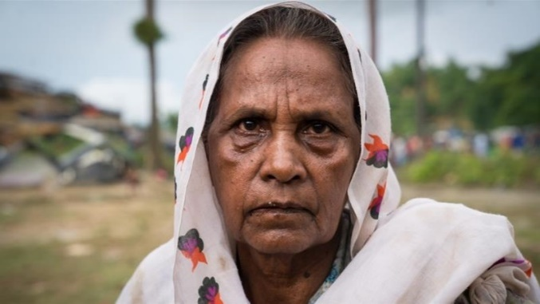
Begum Jaan, 65, comes from Rakhine State, Myanmar, which she fled in recent weeks.

“My life has been one long struggle. My husband died 25 years ago, and since then I have been begging on the streets of my village to survive. Both my daughters are married, so I had no one to support me.
One night I woke up to the sound of guns and explosions - they were so loud; I could not bear it. I have not been able to sleep since as I can still hear those noises in my head. Everyone was fleeing, so I fled with them, I did not want to be left on my own. It took me two days to reach Bangladesh, I found the journey very difficult as I need a walking stick and no one accompanied me, even though I saw lots and lots of people heading to Bangladesh. I had heard the military had ships patrolling the river, so I was very scared when crossing it by boat. Even though I am now in Bangladesh, I am still scared I will run into the Myanmar military. But I am happier now, as I cannot hear the sound of guns or explosions. I feel like the outside world is supporting us a lot and that makes me feel better. I want everyone to hear our story, I want the whole world to hear our sorrows, but I don't know what good it will do. We don't have a future; our lives are hopeless.”

Rashida, a Rohingya
by Katie Arnold 11 Sept 2017 (Al Jazeera)
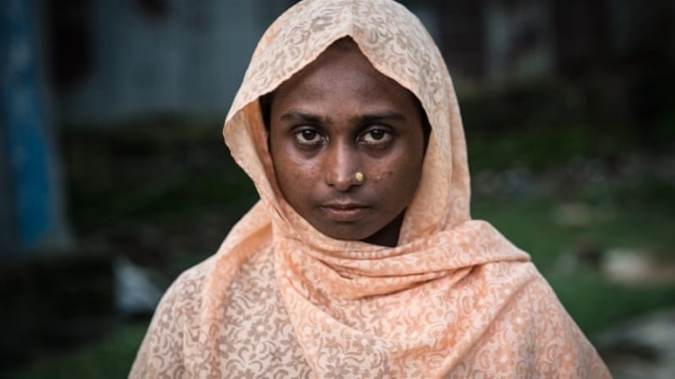
Rashida, 25, comes from Rakhine State, Myanmar, which she fled nine days ago.

“My name is Rashida and I'm 25 years old. Before the Arakan revolution, I lead a very quiet and simple life. We had some paddy fields which we farmed, and I had a house where we lived with my husband and our three children. It was peaceful, and we were very happy until the crisis. We have left all that behind now. Our house and fields have been burned so we cannot earn our living there anymore. When the military started shooting in our village, we quickly took my children into the jungle and hid them; they were scared from the dangers in the wild. But, when I went back to check on the house, I saw right in front of my eyes, that many people had been killed. From the jungle, we walked for eight days until we reached the border. We were very hungry and had nothing to eat except leaves off the trees. The children kept asking for food, but we could not carry anything with us, only my three children. We crossed the border on a small boat, it felt very dangerous and I thought it was going to sink, so I was clutching my children tightly.
I am not happy to be in Bangladesh, we used to own animals, an acre (0.4 hectares) of paddy field, a house and we had a nice village in our own country. We have left all that behind, so I am sure you can imagine how sad we feel. I miss our home. We feel hopeless here, I have no idea what our future will be now. We are not getting enough support here. The Bangladeshi people are being very kind and are donating clothes and food, but I have not seen any international organization. I wish they would help us, too - we need food to eat. My message to the outside world is that we want peace, we have no future without peace.”

Jashim, a Rohingya
by Katie Arnold 10 Sept 2017 (Al Jazeera)
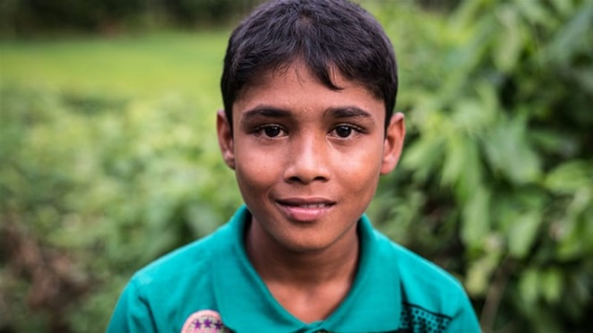
Jashim, 12, comes from Rakhine State, Myanmar, which he fled 13 days ago.

“My name is Jashim and I am 12 years old. Before the crisis, I was at school studying. My favorite subject was English because I thought that if I knew how to speak English then I could communicate with many people across the world and express my opinion to them. I hope I can continue studying soon because I want to become a teacher. When the military came into our village we had to run away and hide. I saw lots of soldiers, maybe 100 or 200. They were shooting at us and burning down our houses - I was very afraid. We hid in the jungle and then started walking to Bangladesh. It took 13 days so sometimes we had to stop in the jungle and make ourselves shelters out of the forest. It was a difficult journey, we crossed big hills and some small rivers. While we were walking, I was always afraid that the military would be around the corner, and just before we reached Bangladesh, we had to be careful because the military had planted little bombs under the ground that would explode if we walked on them. I'm very upset about my village because it's not there anymore. We did not bring anything, so it is all lost. I came with my mother, but my father is still in Rakhine State. He told us to save ourselves and that he would join us at a later date, but we don't know where he is, and we have not heard from him. I'm worried the military found him or he stepped on a small bomb. I'm glad that we are safe, but it is difficult here because there are no houses to live in and we have to sleep on the wet ground. My message to the world is that we are citizens of Myanmar, if they were to declare us citizens, we would be very happy. This is what we want.”

Muhammed Ason, a Rohingya
by Katie Arnold 16 Sept 2017 (Al Jazeera)
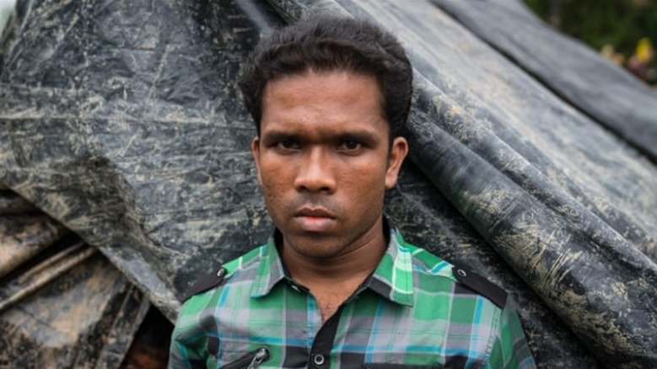
Muhammed Ason, 24, comes from Rakhine State, Myanmar, which he fled a few weeks ago.

"Before the crisis, I was studying English and Burmese at a high school in Rakhine State. I wanted to learn English so I could help the Rohingya community and express their problems to the world. I also ran a grocery shop. I was not very happy in Rakhine State; we had no freedom and I was not allowed to procure goods for my shop from other countries. There were so many restrictions that made our life difficult. I remember when the military came to our village and started shooting, my neighbor could not face the torment, so he tried to fight back with a knife. They shot him dead, right in front of my eyes. They have been torturing us for years, beating us and restricting our movement, but now they are shooting us - I could not live that way, so I fled to Bangladesh. I have no words that can explain how sad I am to have left my village, everything I own is there - the only thing I could carry was a spare longyi (a garment worn about the waist common to Myanmar). But I am more afraid for the Rohingya who remained, who knows what will happen to them. I do not like it in Bangladesh, we have to sleep by the side of the road, it's wet and muddy and we have not received enough support. The number of Rohingya here is so huge, the Bangladeshi people are trying to help, and some organizations are here but it is too little for the sheer number of Rohingya living in these conditions. The world needs to put pressure on the Myanmar government to let us go back to our own country. Bangladesh is not our country; the people here tell us that we are Rohingya and that we are Burmese. We are from Rakhine State and that is where we belong. My request to the world is please help us get our own rights within Myanmar. The Buddhist live in peace, so why can't we - I want to live like them. The Buddhist can follow Buddhism and we will follow Islam. We don't want a religious conflict; we just want to follow our religion in the same way they do."

Rahimol, a Rohingya
by Katie Arnold 12 Sept 2017 (Al Jazeera)
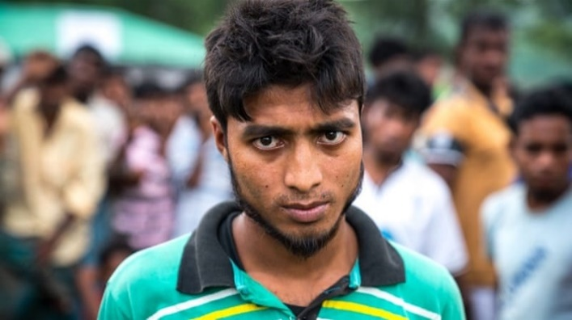
Rahimol, 22, comes from the village of Foira, Rakhine State, Myanmar, which he fled a few weeks ago.

“My name is Rahimol Mustafa and I am 22. Before arriving here, I was a student at the local madrassa [religious school]. I really enjoyed my religious studies and sometimes I would teach the younger children too, as most of the people I lived with were uneducated. My aim was to become a teacher and I was very happy in my village of Foira, until the military came along. It was 3am when the military started firing their guns at our village and burning down our houses. We could not leave the house because if they saw us, they would shoot, so we hid inside. Eventually, they reached our house and started firing their guns through the window, a bullet hit my knee. Many people from our village died that night. I personally saw three neighbors killed. My father and brother took me to a hospital for medical treatment, but the hospital wouldn't accept me because of the fighting, so my relatives carried me to Bangladesh. They carried me through the mountains in order to avoid the military. It was a very long and painful trip and my wound became severely infected. I felt so sad because the only thing my family could carry was me, we left everything else behind. I am grateful that we have reached safety in Bangladesh and I have received some medical help from MSF [Doctors Without Borders, which is often known by its French initials], but we have no shelter and no future. We will only have a future if there is peace at home. It is so sad what is unfolding in front of our eyes. We want to go home, and we want peace. But I believe the world is watching our crisis and that they are trying to help us.”

