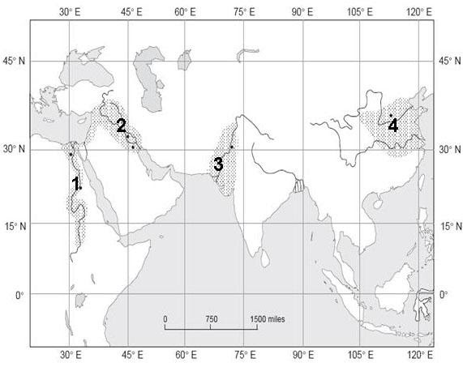
Using the Map above, please list each river valley and it’s latitude and longitude: (use the dot for the city when determining the coordinates.

- _________________River Valley _______North________East

- _________________River Valley _______North________East

- _________________River Valley _______North________East

- _________________River Valley _______North________East

