Illegal Poaching in Africa

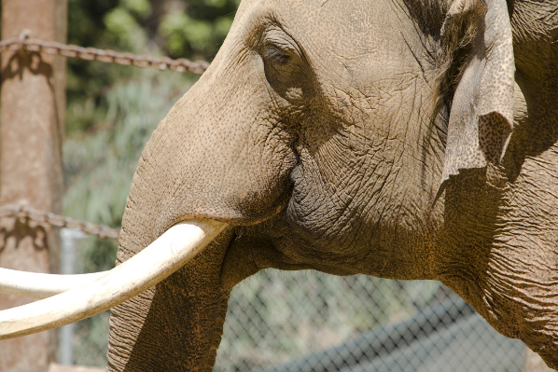
Illegal poaching and trade of endangered animals has been a huge issue in Africa for many years. Even today, despite great efforts by African wildlife authorities and environmental groups, the killing goes on. Earlier this year, over 1,200 tusks were discovered in Tanzania, a sign that the situation is still nowhere near where it should be. It is therefore understandable that conservation groups such as IFAW should be outraged at the recent proposals being put forward by governments for a limited legal trade in certain animal products. However, as is so often the case, the argument is a complicated one, and it’s difficult to judge what is best. The two most poignant cases concern the elephant and the rhino, both species that were severely threatened during the poaching era of the 1980s.

The Elephant Issue
Elephant poaching
The elephant population of South Africa has grown steadily thanks to the great efforts employed by conservation groups and wildlife authorities in Africa. Nevertheless massive numbers of elephants are killed every year illegally to feed the ever-hungry black market in ivory.

Recently the South African government made a proposal concerning the sale of ivory and elephant hides stockpiled by their national parks through natural mortality and problem animal control. The money from these sales would be put back into their parks and would help fund activities such as elephant management programmes, control of illegal hunting of elephants, and creating more and larger protected areas for the elephants to be re-established in. The items sold would come from legitimate sources – materials seized from illegal traders would not be included in the trades. The proponents of this proposal claim it would provide a sustainable way of maintaining the conservation efforts of the African elephant.

Conservationists take a different view. They warn that opening up a legal ivory trade would encourage ‘the proliferation of illegal activities such as poaching, and thus associated illegal markets.’ They reason that creating a legal ivory market would serve only to support the growth of current markets in poached ivory. This would undermine the efforts that the governments are attempting to support through the proposed legal market. Instead, the groups suggest that the governments invest in creating a healthy eco-tourism industry, which would benefit everyone, both financially and ecologically.

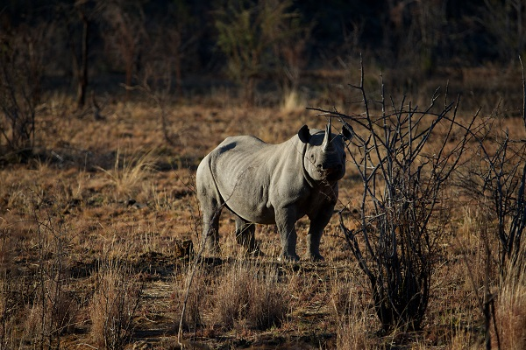
Rhino Reservations

The same debate is rife over the protected Rhinos of South Africa – the black rhino, whose overall population in Africa has decreased by 83% since 1980, and the white rhino, whose numbers had been reduced to just 20 at the turn of the century. Again there are two opinions regarding the market for these animals’ assets.

Some believe that trade in rhino horn and other by-products should be made legal, as it would in fact encourage people to breed them for commercial purposes, which would allow the wild populations to thrive. Making it legal and more widely available would also decrease its value, and lessen the attraction for poaching and trading in the substances, as they become less precious. A legal market would be much easier to control and regulate, and the money gained could go towards funding further conservation efforts.

Again the argument has two sides, and conservationists believe that such a market would be disastrous in terms of its effects on the rhino population and the popularity of poaching. Similar to the proposals concerning ivory and other elephant derived materials, the groups insist that once a legal market is opened, it would become almost impossible to control or regulate the illegal trade through poaching of the animals.

The proposals in question primarily involve down listing the animals in the Convention on International Trade in Endangered Species (CITES) Appendix from Appendix I – whereby trade in products or live animals is illegal – to Appendix II, which would allow for trade in live animals, leather goods and ‘the non-commercial trade of sporting trophies’. The move is opposed by Kenya and India, who both maintain an anti-trade stance.

To some it seems a difficult choice but the benefits and costs are clear and poignant. Most arguable is the point that ivory and rhino horn are products which should be removed from the world market altogether. No-one needs them for survival, and those who benefit from the sales could benefit equally from a developed and established eco-tourism industry which would bring wealth and business interests to the countries while benefiting and supporting the wildlife and local people. Yet R25.91 million worth of ivory and hide stockpiles remain in Kruger National Park in South Africa. Should these be used to support further developments of conservational programmes, at the risk of worsening the threat of death to the very animals they protect? Or should they be left untouched in support of the zero-quota principle, at the loss of the precious financial help which their sale could provide for the cause? Let us know what you think.

