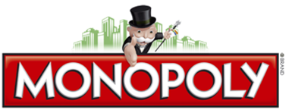
Names of Group Members: Money(CASH) for each player: Community Chest/Chance Cards
1.____________________________________________________________________________________
2.____________________________________________________________________________________
3.____________________________________________________________________________________
4.____________________________________________________________________________________
5.____________________________________________________________________________________

Round 1: Capitalism- End of Day 1
Properties: Write your name/initials beside each property that you own and how many houses/hotels on each.
Atlantic Avenue
B & O Railroad
Baltic Avenue
Boardwalk
Connecticut Avenue
Electric Company
Illinois Avenue
Indiana Avenue
Kentucky Avenue
Marvin Gardens
Mediterranean Avenue
New York Avenue
North Carolina Avenue
Oriental Avenue
Pacific Avenue
Park Place
Pennsylvania Avenue
Pennsylvania Railroad
Reading Railroad
Short Line
St. Charles Place
St. James Place
States Avenue
Tennessee Avenue
Ventnor Avenue
Vermont Avenue
Virginia Avenue
Water Works

