Name________________________________________________Period_______________________

Africa Regional Jigsaw

Use the assigned chapter to answer the following questions in relation to your area. Illustrate each question.
Identify your region on the map provided by shading in the area RED or providing a map of your assigned section.

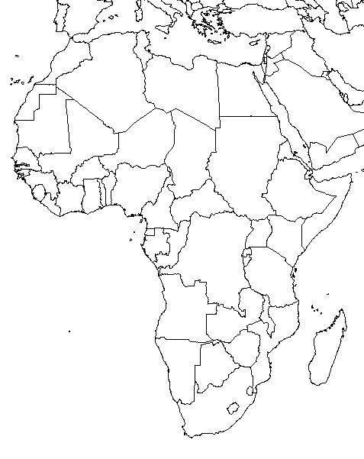
West Africa: Ch. 22: 527-548

- What are the landforms of your assigned section?

- What are the climates, plants and animals of your region?

- What are the Natural Resources of your region?

- Give at least 4 events in your region’s early history.
Choose the most significant. YOU MAY USE MORE

a.

b.

c.

d.

- Give at least 4 cultural characteristics and explain each one. Include People, language, land use, settlement, religion, traditions and customs. YOU MAY USE MORE
a.

b.

c.

d.

The Region Today:
What is the region’s main economy and does that impact their country globally?

PART 2: Read your assigned section and answer the questions given. Explain each one.

West Africa: Blood Diamonds
Pages 542-543

- What is the problem? Summarize in your own words:

2. Why do you think these diamonds are called “conflict diamonds”? EXPLAIN

3. How does the demand for diamonds in other parts of the world fuel civil war and conflict in Africa?

4. What are the possible solutions to the problem?

