Rwanda genocide: 100 days of slaughter
7 April 2014
- Share
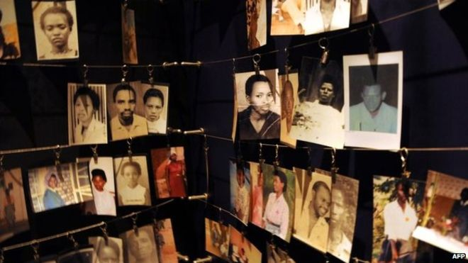Image copyrightAFPImage captionThere are numerous memorials around Rwanda to those killed in the genocide
In just 100 days in 1994, some 800,000 people were slaughtered in Rwanda by ethnic Hutu extremists. They were targeting members of the minority Tutsi community, as well as their political opponents, irrespective of their ethnic origin.

Why did the Hutu militias want to kill the Tutsis?
About 85% of Rwandans are Hutus but the Tutsi minority has long dominated the country. In 1959, the Hutus overthrew the Tutsi monarchy and tens of thousands of Tutsis fled to neighbouring countries, including Uganda. A group of Tutsi exiles formed a rebel group, the Rwandan Patriotic Front (RPF), which invaded Rwanda in 1990 and fighting continued until a 1993 peace deal was agreed.
On the night of 6 April 1994 a plane carrying then President Juvenal Habyarimana, and his counterpart Cyprien Ntaryamira of Burundi - both Hutus - was shot down, killing everyone on board. Hutu extremists blamed the RPF and immediately started a well-organised campaign of slaughter. The RPF said the plane had been shot down by Hutus to provide an excuse for the genocide.
How was the genocide carried out?
With meticulous organisation. Lists of government opponents were handed out to militias who went and killed them, along with all of their families. Neighbours killed neighbours and some husbands even killed their Tutsi wives, saying they would be killed if they refused. At the time, ID cards had people's ethnic group on them, so militias set up roadblocks where Tutsis were slaughtered, often with machetes which most Rwandans kept around the house. Thousands of Tutsi women were taken away and kept as sex slaves.

Did anyone try to stop it?
The UN and Belgium had forces in Rwanda but the UN mission was not given a mandate to stop the killing. A year after US troops were killed in Somalia, the US was determined not to get involved in another African conflict. The Belgians and most UN peacekeepers pulled out after 10 Belgian soldiers were killed. The French, who were allies of the Hutu government, sent a force to set up a supposedly safe zone but were accused of not doing enough to stop the slaughter in that area. Rwanda's current president has accused France of taking part in the massacres - a charge denied by Paris.

Why was it so vicious?
Rwanda has always been a tightly controlled society, organised like a pyramid from each district up to the top of government. The then governing party, MRND, had a youth wing called the Interahamwe, which was turned into a militia to carry out the slaughter. Weapons and hit-lists were handed out to local groups, who knew exactly where to find their targets.
The Hutu extremists set up radio stations and newspapers which broadcast hate propaganda, urging people to "weed out the cockroaches" meaning kill the Tutsis. The names of those to be killed were read out on radio. Even priests and nuns have been convicted of killing people, including some who sought shelter in churches.

How did it end?
The well-organised RPF, backed by Uganda's army, gradually seized more territory, until 4 July, when its forces marched into the capital, Kigali. Some two million Hutus - both civilians and some of those involved in the genocide - then fled across the border into DR Congo, at that time called Zaire, fearing revenge attacks.
Human rights groups say the RPF killed thousands of Hutu civilians as they took power - and more after they went into DR Congo to pursue the Interahamwe. The RPF denies this. In DR Congo, thousands died from cholera, while aid groups were accused of letting much of their assistance fall into the hands of the Hutu militias.

