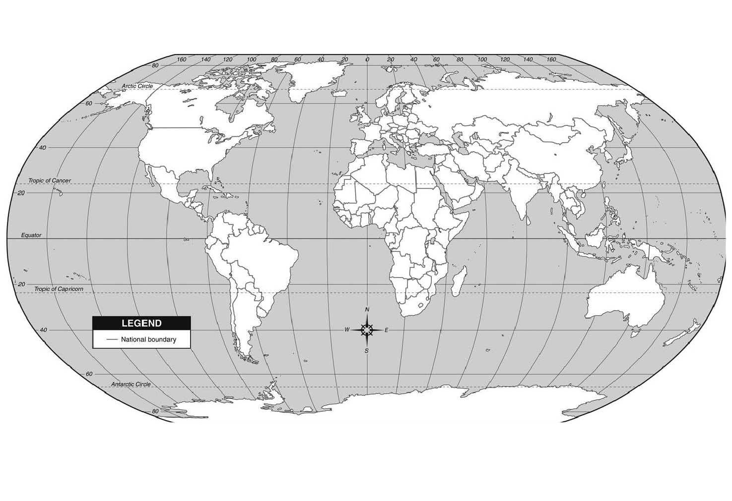
WORLD MAP (MAP 1)
Name_________________________________
Period_____________
World Map (Global Skills/World Continents/Oceans
[Grab your reader’s attention with a great quote from the document or use this space to emphasize a key point. To place this text box anywhere on the page, just drag it.]

World Map (Global skills/World Continents/Oceans) Directions: Use your text or a reference map to locate and label the following Physical and Political features on the World Map provided.
*Label all Continents and outline them in BROWN pencil.: North America, South America, Africa, Europe, Asia, Australia, and Antarctica.
*Label all Oceans and color them BLUE: Atlantic, Arctic, Pacific, Indian, and the Southern Ocean
*Mapping Tools: Label the Equator, Prime Meridian, Tropic of Cancer, and the Tropic of Capricorn, Arctic Circle, and Antarctic Circle and outline them in RED.

‘
Map 2: For Practice

WORLD MAP (Map 2)
World Map (Global skills/World Continents/Oceans) Directions: Use your text or a reference map to locate and label the following Physical and Political features on the World Map provided.
*Label all Continents and outline them in BROWN pencil.: North America, South America, Africa, Europe, Asia, Australia, and Antarctica.
*Label all Oceans and color them BLUE: Atlantic, Arctic, Pacific, Indian, and the Southern Ocean
*Mapping Tools: Label the Equator, Prime Meridian, Tropic of Cancer, and the Tropic of Capricorn, Arctic Circle, and Antarctic Circle and outline them in RED.

